

Embedded AI (tinyML) for Object Detection
Software and Engineering for Embedded Systems

Deniz Dag
Murat Kezlev

Embedded AI (tinyML) for Object Detection

Abstract
This report presents the design, training, deployment, and evaluation considerations of an embedded artificial intelligence (tinyML) object detection system implemented using Edge Impulse Studio and deployed on an ESP32-S3 development board. The project investigates the feasibility of executing lightweight computer vision inference on resource-constrained hardware through the FOMO object detection architecture. The study focuses on the detection of three vehicle classes and documents the dataset preparation process, model configuration, hyperparameter selection, embedded deployment strategy, and software implementation.
The target object categories considered in this project are car, bus, and motorcycle. The resulting report is structured as a formal master’s project submission document, covering the technical background, experimental workflow, implementation details, and deployment rationale associated with the proposed system.

1. Introduction
Embedded machine learning has emerged as an effective approach for enabling intelligent perception on low-power devices with limited memory and computational capacity. Within this context, Edge Impulse provides an end-to-end development environment for data collection, labeling, training, optimization, and deployment of machine learning models for embedded platforms. For vision-based object detection tasks, the platform supports the FOMO (Faster Objects, More Objects) architecture, which is based on a lightweight MobileNetV2 backbone and is designed for deployment on highly resource-constrained hardware.

2. Methodology

2.1 Dataset Preparation
The dataset used in this project was compiled from publicly available sources, including Kaggle datasets containing both labeled and unlabeled vehicle images, as well as the Roboflow Car Modal dataset. The original data included annotations for six vehicle categories; however, only the labels relevant to the present study were retained.
Images without annotations were manually labeled within the Edge Impulse environment.
The labeled Kaggle data were filtered to remove non-target classes using Roboflow and were subsequently exported in YOLOv8 format.
The Roboflow Car Modal dataset was likewise exported in YOLOv8 format.
All YOLOv8-formatted datasets were then imported into Edge Impulse for training and evaluation.
The dataset was divided into training and test partitions using an 80%–20% split, respectively.

2.2 Model Configuration in Edge Impulse
In Edge Impulse, an impulse defines the processing pipeline that transforms raw input data into features and subsequently applies a learning block for classification or detection on previously unseen data. For the object detection task addressed in this study, the impulse configuration is largely determined by the selected detection architecture, with the image-processing settings constituting the principal user-adjustable parameters.
For the present object detection task, the impulse configuration offers limited variation, as the overall pipeline is largely predefined by the selected model architecture.
Image Data is generated by default and constitutes the primary user-configurable component of the impulse definition.
- Image Width and Height: Recommended 96x96
- Resize Mode: Recommended value Fit Shortest Axis. Fit Longest Axis and Squash are other options.
- Train on data subset: Train using 100%. Train on a subset percentage of the dataset to accelerate feature generation and training.
The processing block is configured as Image, which is the standard selection for image-based object detection tasks.
The learning block is configured for Object Detection.
The output features are inferred automatically from the class labels defined in the dataset.
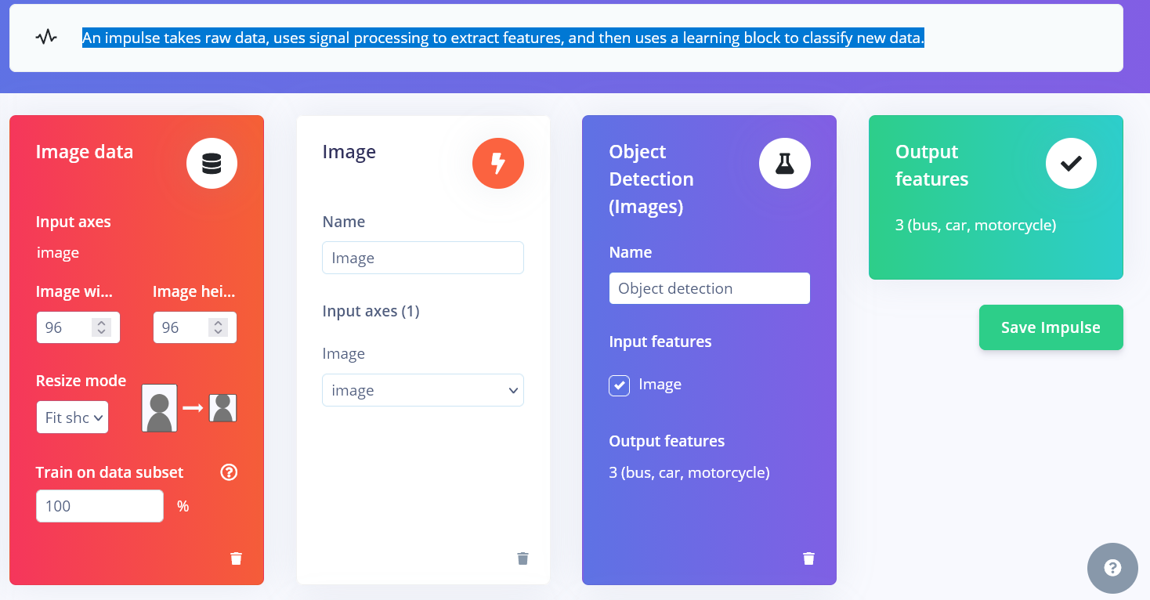
Figure 1 – Impulse Settings

2.3 Image Preprocessing and Normalization
When configuring the image data block in Edge Impulse, selecting grayscale instead of RGB (color) as the color-depth parameter represents one of the most significant optimizations for an embedded computer vision pipeline.
In Grayscale Conversion, the RGB input is converted to grayscale using the ITU-R BT.601 standard (Y' component only), which calculates luminance as follows [1], [2]:
Luminance = (0.299 × R) + (0.587 × G) + (0.114 × B) [1].
For resource-constrained hardware such as the ESP32, the use of grayscale is a deliberate engineering decision motivated by three primary considerations.
1)RAM and Memory Savings
By selecting grayscale, the image memory footprint is reduced by approximately 66.6%.
For example, data size before it even enters a model like FOMO:
- 96 x 96 RGB Image: 96 x 96 RGB x 3 bytes=27,648 bytes
- 96 x 96 Grayscale Image: 96 x 96 RGB x 1 bytes=9,216 bytes
Because the microcontroller must simultaneously store the raw camera frame buffer, the resized image tensor, and intermediate neural network activations in SRAM, a saving of approximately 18 KB per frame can be decisive in preventing out-of-memory errors and ensuring stable execution.
2) Faster inference speed
Since a grayscale image contains a single channel rather than three, the first convolutional layer of the neural network requires substantially fewer weights and arithmetic operations.
This reduction in computation enables the processor to complete a full forward pass more rapidly. In practice, when the ESP32 executes a FOMO model, switching from RGB to grayscale can lead to a meaningful improvement in inference performance.
3) Emphasis on structural features rather than spurious predictors
In many tinyML applications, such as object counting, shape detection, and structural feature tracking, color information contributes little to model performance and may instead introduce unwanted variability. For models designed to localize objects, count instances, or identify geometric patterns, grayscale is often the more appropriate engineering choice.
- Training a FOMO model to detect and count specific mechanical parts or target markers, the model needs to learn edges, textures, and geometry.
- Training in RGB, the model might accidentally over-rely on lighting shifts or color variations rather than the actual shape of the object.
By eliminating color information, the feature extractor (MobileNetV2) is encouraged to focus on structural contrast and gradients, which can improve model robustness under variable real-world lighting conditions.
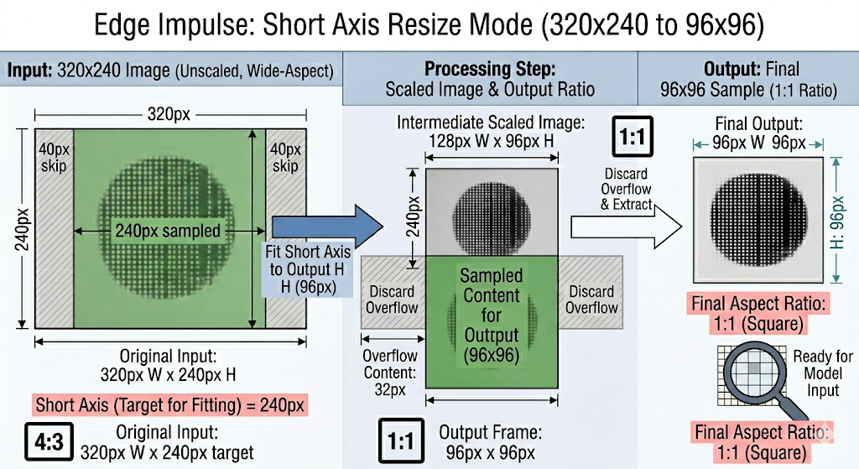
Figure 2 - Image Resize
Note: In tasks where color constitutes a discriminative feature—for example, distinguishing a ripe red tomato from an unripe green tomato, or sorting wires by color bands—RGB input remains essential.
The Normalization Process
When selecting "Grayscale" as the color depth in the impulse, the following steps occur during both feature generation and inference [1], [2]:

2.4 Object Detection Architecture
For deployment on the ESP32 platform, FOMO (Faster Objects, More Objects) MobileNetV2 0.1 is the most suitable architecture among the options provided by Edge Impulse.
For deployment on the ESP32 platform, FOMO (Faster Objects, More Objects) MobileNetV2 0.1 is the most suitable architecture among the options provided by Edge Impulse [3], [4].
How FOMO Works: The Grid System [3], [4]
Conventional object detection methods attempt to predict bounding boxes by estimating the precise width and height of each object, a process that imposes considerable computational and memory overhead. FOMO reduces this burden by adopting two simplifying assumptions.
- Centroids over Boxes: You don't usually need to know how "big" a car is; you just need to know where it is. FOMO finds the center (centroid) of the object instead of its boundaries.
- The Heat Map: FOMO divides your image into a grid of small cells (usually 8x8 pixels each). It then runs a classifier on every cell simultaneously.
If you have a 96x96 pixel image and use an 8x8 grid, the model outputs a 12x12 "heat map." Each cell in that map tells the ESP32: "In this specific 8x8 patch of the image, there is a 90% chance of a car."
Reasons for suitability on the ESP32-S3
- Speed: FOMO is roughly 30x faster than MobileNet SSD. On the ESP32-S3, you can achieve 10–20 frames per second, whereas YOLO might take several seconds per frame.
- Memory: It can run in less than 200KB of RAM. Since the ESP32-S3 has 512KB, this leaves plenty of room for your camera buffer and other code logic.
- Counting: Because it works on a grid, it is naturally very good at counting many objects (like multiple cars in a parking lot) without needing the complex "Non-Maximum Suppression" math that YOLO requires.
The "Trade-offs"
These advantages are achieved at the cost of several limitations.
- No Size Detection: FOMO won't tell if a car is "large" or "small" in the frame. It assumes all objects are roughly the same size as the grid cells.
- Minimum Distance: If two objects are so close that their centers fall into the same grid cell, FOMO will only count them as one object.
- Square Assumption: FOMO works best when objects are somewhat square or circular. Extremely long, thin objects can sometimes confuse the grid.

2.5 Training Hyperparameters
When configuring hyperparameters for edge machine learning models, the optimization strategy differs substantially from that used in conventional deep learning. Because such models must operate within the strict memory and computational constraints of microcontrollers, hyperparameter selection must carefully balance convergence, stability, and deployability.
1. Learning Rate (LR)
The learning rate determines the step size used by the optimizer while minimizing the loss function.
- FOMO Baseline Recommendation: Start at 0.001. Because FOMO uses a highly truncated backbone, a massive learning rate will instantly cause the loss function to explode
- The Tuning Rule: If the validation loss curve looks jagged or stalls immediately, drop the learning rate to 0.0005 or 0.0001 to stabilize gradient updates.
- Interplay with Batch Size: Scaling up the batch size to process more images at once, can step up the learning rate proportionally to speed up training dynamics without destabilizing the network.
2. Training Cycles (Epochs)
A training cycle, or epoch, represents one complete forward and backward pass through the entire training dataset.
- Standard Starting Range: 60 to 120 cycles.
- Adjusting for Augmentation: When data augmentation enabled, increase your training cycles to 150 to 300 cycles. Data augmentation continuously introduces random synthetic adjustments to the data. The network needs more time (epochs) to process these variations and find the underlying mathematical pattern instead of simply memorizing raw pixel locations.
- Monitoring Overfitting: Stop increasing cycles if you notice your training loss dropping continuously while your validation loss begins climbing upward—this indicates the network is overfitting to your training set.
3. Data Augmentation
Data augmentation introduces random transformations to the training images during model training, thereby encouraging the network to learn generalizable structural patterns rather than memorizing superficial details.
- Recommended for a small dataset (e.g., fewer than 100-200 images per class) to prevent rapid overfitting.
- Data augmentation happens exclusively during the cloud training phase. It has absolutely zero impact on the final RAM, Flash storage, or processing latency of the compiled model once flashed to the microcontroller.
4. Batch Size
Batch size denotes the number of image samples processed before the model parameters are updated.
- Standard Edge Recommendation: 32 or 64.
Why Keep it Low?
- Noisy Gradients: Smaller batch sizes (like 32) produce noisier, more diverse gradient updates. This slight randomness is actually beneficial for small networks because it helps the model escape local minima and generalize better to real-world inputs.
- Cloud Processing Walls: Setting a massive batch size (like 256+) can cause the cloud compilation workers to time out or exhaust memory limits if your input images are large.
5. Profile Int8 Model
The choice between a quantized INT8 model and an unoptimized FLOAT32 model represents a standard deployment trade-off between computational efficiency and numerical precision.
Model optimizations and performance - Quantized (int8)
- Hardware Acceleration: The ESP32-S3 has a specialized instruction set (called "S3 AI instructions") designed to accelerate 8-bit integer math. Choosing float32, will bypass this hardware acceleration, and the model will run much slower.
- Internal Memory (SRAM): The ESP32-S3 has limited internal memory. A float32 model is 4 times larger and requires significantly more RAM during calculations. If the model gets too big, it will fail to initialize or force to use slower external PSRAM.
- Battery Life: Because the processor finishes the math faster with int8, it can return to a low-power state sooner, extending the battery life.
Quantized (int8)
 | Image | Object detection
Latency | 15 ms. | 880 ms.
Ram | 4.0K | 149.7K
Flash | - | 54.8K
Accuracy

To feed a trained FOMO model, the input must match the same preprocessing and normalization pipeline adopted during model training [4], [5].
- Match Dimensions: The image must be square and resized to the exact dimensions specified in your Impulse (e.g. 96x96).
- Number of images: “Aim around 80–100 images per class for good performance with as much background variation as possible to ensure good background suppression”.
- Image Background: White only backgrounds might prevent the model from learning to distinguish against backgrounds.
- 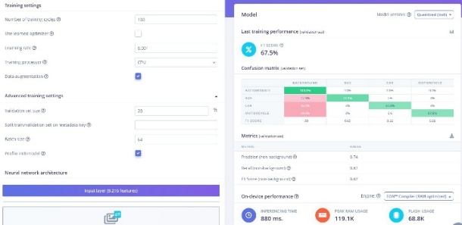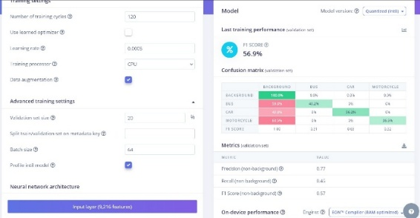

- 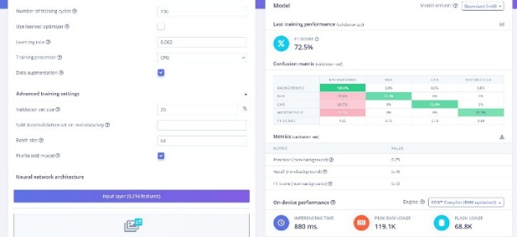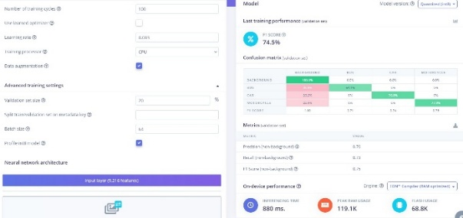

3. Deployment Strategy
Deployment target. The selected deployment target is the Arduino Library format. Edge Impulse Studio generates the model as an Arduino-compatible library, which can then be imported into the Arduino IDE as a ZIP package.
Edge Impulse EON Compiler as Inference Engine [6]
EON is an ahead-of-time (AOT) compiler that takes the TensorFlow Lite flatbuffer representation of the trained model, analyzes its execution graph, and translates the network into optimized C++ source code.
Because the neural network is compiled directly into code, the need for an interpreter at runtime is eliminated. Consequently, the microcontroller executes a sequence of predefined C++ operations rather than dynamically parsing the model structure during inference.
TensorFlow Lite for Microcontrollers (TFLM) [7]
By contrast, TensorFlow Lite for Microcontrollers (TFLM) uses an interpreter-based runtime. During startup, the ESP32 allocates a tensor arena in RAM, loads the model from a .tflite flatbuffer, parses the computation graph at runtime, and prepares the data flow between network layers.
This interpreter-based approach consumes additional flash memory and introduces graph-management overhead in RAM.

4. System Implementation
The software implementation is based primarily on the esp32_camera example provided within the Edge Impulse Arduino Library for the inference stage. In addition, the ESP32 camera library example was used as a reference for camera acquisition and preprocessing operations.

void capture_and_infer()
This function orchestrates the complete Edge AI execution cycle.
- flashes an indicator LED,
- captures a raw grayscale image from the camera framebuffer,
- preprocesses the pixel array,
- triggers local Edge Impulse machine learning inference.
- The execution includes safety validation checks for formats,
- releases critical buffers back to the hardware pool as fast as possible

bool init_camera()
This function initializes the camera sensor configuration, validates the sensor handle, and applies hardware-specific defaults such as vertical image flipping and grayscale optimization.
@return true if the camera was successfully initialized or was already active.
@return false if the initialization failed or the sensor pointer could not be retrieved.

static void run_inference(const uint8_t* model_input)
This function executes local inference using the Edge Impulse SDK. It wraps the preprocessed camera frame buffer into an Edge Impulse signal structure, invokes the classifier, and reports runtime performance together with the raw model outputs, such as centroids for object detection or class probabilities.
@param model_input Pointer to the constant uint8_t array containing the preprocessed image feature data (e.g., a 96x96 grayscale buffer).

void init_ble()
This function initializes the Bluetooth Low Energy (BLE) stack and configures the GATT server.
It defines a custom device name, registers server callbacks, provisions a primary service with read and notify characteristics, and starts advertising so that external client applications can discover and connect to the device.

void print_status(String message)
This function routes status messages simultaneously to multiple output interfaces.
- The hardware Serial monitor,
- A 16x2 character LCD, and
- Any connected BLE client.
The implementation handles basic string truncation and two-line wrapping for the character display and verifies the global connection state before transmitting BLE notifications.
@param message The Arduino String payload containing the text to broadcast.

static inline uint8_t* crop_and_resize(const uint8_t* src, size_t src_len)
This function applies the Edge Impulse fit shortest axis crop-and-resize operation to a raw grayscale camera frame.
@param src Grayscale row-major buffer, CAM_W × CAM_H bytes.
@param src_len Must be >= CAM_W * CAM_H.
@return Pointer to 96×96 output in ei_input_buf[], or NULL on error.
static int ei_camera_get_data(size_t offset, size_t length, float, out_ptr)
This function serves as an abstraction layer for data retrieval within the Edge Impulse signal wrapper.
It maps requests from the inference engine to the preprocessed camera frame buffer and iteratively normalizes each pixel from an 8-bit integer representation to a floating-point value in the range 0.0–1.0.
@param offset The starting position within the target feature stream.
@param length The total number of signal elements (pixels) to read and normalize.
@param out_ptr Pointer to a float array where the normalized pixel values (0.0, 1.0) will be populated for the classifier.
@return 0 indicating a successful memory map, conversion, and read operation.

5. Conclusion
This project demonstrates the practical deployment of a tinyML-based object detection system on a resource-constrained embedded platform. By combining curated vehicle datasets, Edge Impulse’s FOMO architecture, grayscale preprocessing, and embedded-oriented optimization strategies, the project establishes a complete workflow from dataset preparation to on-device inference. The implementation highlights the trade-offs between computational efficiency, memory usage, and detection capability, and shows that lightweight object detection on microcontrollers is feasible when model design and deployment decisions are aligned with hardware constraints. Future work may extend the dataset, incorporate more comprehensive evaluation metrics, and investigate comparative performance across alternative embedded inference frameworks.

References
[1] “Image block,” Edge Impulse Documentation Available: docs.edgeimpulse.com.
[2] “Transfer Learning on Greyscale Images: How to Fine-Tune Pretrained Models on Black-and-White Images,” Towards Data Science.
[3] Edge Impulse FOMO
[4] “Object detection with centroids,” Edge Impulse Documentation
[5] "Introducing Faster Objects More Objects aka FOMO" | by Peter Ing | Medium
[5] “EON Compiler,” Edge Impulse Documentation
[6] TinyML at the Edge: 5 Frameworks Powering IoT
[7] Tiny Machine Learning Kit
[8] Object detection with bounding boxes
[9] Example - ESP32-CAM Object Detection with Edge Impulse

